**Operation Manual**

**Premium Loyalty Program**

*Ascena Brands*



Table of Contents

1 Document Revision History 4

2 Program Overview 4

2.1 Overview 4

2.2 Overview of Functionality and Key Processes 4

2.2.1 Outbound Transaction Feed 4

2.2.2 Outbound Account Update Feed 5

2.2.3 Outbound Adjustment Feed 5

2.2.4 Outbound Account Update Reporting Feed 5

2.2.5 Outbound Account Summary Reporting Feed 5

2.2.6 Outbound Account Certificate Reporting Feed 5

2.2.7 Outbound Transaction Reporting Feed 5

2.3 Contributing Applications and Services 5

2.4 Scheduled Events 5

2.5 Infrastructure and Design 6

2.5.1 Integration Context Diagram – Inbound Highlighted 6

2.5.2 Inbound Data Feeds to the EDL 7

2.5.3 Integration Context Diagram – Outbound Highlighted 7

2.5.4 Outbound Data Feeds from the EDL 8

3 Security and Access Control 9

4 Program Configuration 10

5 Configuration Management 10

5.1 Code Repository 10

5.2 Backup and Restore Procedures 10

5.2.1 GIT Backup and Restore (recommended) 10

5.2.2 CommVault Backup and Restore 10

5.2.3 Online Backup and Restore 11

6 Monitoring and Alerting 11

6.1 Daily Operational Monitoring and Alerting 11

6.2 Error Messages 12

6.3 Health Checks 12

7 Operational Tasks 12

7.1 Deployment 12

7.2 Troubleshooting 13

8 Maintenance Tasks 13

8.1 Maintenance Procedures 13

8.1.1 Code Branching 13

8.1.2 Code Review 13

8.1.3 Code Merging 13

8.2 Testing (pre deployment) 13

8.3 Validation (post deployment testing) 13

9 Failure and Recovery Procedures 13

9.1 Troubleshooting 13

9.2 Rerunning TWS Jobs 13

10 Contact Details 14

11 Additional Document References 14

12 Appendix 15

Table of Figures

Figure 1: Integration Context Diagram – Inbound Highlighted 7

Figure 2: Integration Context Diagram – Outbound Highlighted 8

Table of Tables

Table 1: Scheduled Events 6

# Document Revision History

| Date | Author | **Revision Description** |
| --- | --- | --- |
| 2019/08/16 | George Brown | Initial Version |
|  |  |  |
|  |  |  |
|  |  |  |

# Program Overview

## Overview

|  |  |
| --- | --- |
| **Purpose** | To support the core component of the Premium (ANN Brands) loyalty system, the EDL team developed a set of outbound data feeds and configured a set of inbound data feeds to / from a 3rd party vendor (Kobie).  The core component of the outbound feed is delivery of transaction data (header and detail) which Kobie uses to calculate and award points to loyalty members. Other ancillary outbound feeds append customer attributes to the loyalty members and pass through “global spend” points (points awarded by co-branded credit cards with purchases outside of our brands – grocery stores, gas stations, theaters).  The inbound feeds include loyalty member information, summary of member points and status of member certificates sent from Kobie’s system. |
| **Document Scope** | This operation manual will contain documentation regarding the core components of the premium loyalty program only and only within the scope of the EDL team’s responsibility. Documentation on proceeding or succeeding processes or programs will not be included in this operation manual. However, proceeding or succeeding documentation may be referenced. |

## Overview of Functionality and Key Processes

### Outbound Transaction Feed

This outbound feed sends transaction header and detail information to FMW (Fusion Middle Ware) for final transformation prior to sending to Kobie. This feed includes all transactions (those that include loyalty IDs as well as those that do not) for all channels (POS and ECOM) and all types (Original Transactions and Returns). The transactions include all required data as per the “EDL to FMW Interface Agreement.xlsx” spreadsheet. Kobie first looks for a loyalty ID in the transaction and if they match to an active member in their system, they will award points based on the transaction details. If no valid loyalty ID exists, Kobie will attempt to look up the active member by email address included with the transaction. If they are able to match to an active member in their system, they will award points based on the transaction details. Otherwise, no points will be awarded for the transaction.

### Outbound Account Update Feed

This outbound feed sends updated account data to Kobie. Kobie is the system of record for all loyalty members; however, to meet the needs of functionality on Kobie’s portion of the loyalty application, data is required from Ascena. This includes indicators for card holder, online profile completion, and other customer identifying attributes. The required data is found in the “Premium Loyalty Program - EDL to Kobie Interface Agreement.xlsx” spreadsheet. Currently the process will check the values found for the indicators and attributes during its previous execution and if different, will include those changes in the feed to Kobie.

### Outbound Adjustment Feed

This outbound feed sends points to be added to Kobie accounts for miscellaneous activities. Currently this feed sends points awarded from CBCC activity outside of ANN stores (Grocery stores, gas stations, movie theaters; AKA “Global Spend”) which is calculated by ADS. Kobie simply receives this feed and applies the points to the loyalty member’s account. This feed could be extended in the future to include points awarded from other sources or other activities (campaigns, lotteries, etc.); this feed is not tightly coupled to “Global Spend” from ADS.

### Outbound Account Update Reporting Feed

This outbound feed sends the latest account update batch *received* by Kobie merged with the latest Ascena updates *sent to* Kobie, to the premium loyalty dashboard. The latest account information (either from Kobie or the EDL) is passed along to ensure that the premium loyalty dashboard receives Ascena updates at the same time they are sent to Kobie, decreasing the chance of “out of sync” issues. **NOTE:** All PII data is removed from this feed.

### Outbound Account Summary Reporting Feed

This outbound feed sends the latest account summary batch received from Kobie. **NOTE:** All PII data is removed from this feed.

### Outbound Account Certificate Reporting Feed

This outbound feed sends the latest account certificate batch received from Kobie. **NOTE:** All PII data is removed from this feed.

### Outbound Transaction Reporting Feed

This outbound feed sends a copy of the daily transaction header and details sent to Kobie. **NOTE:** All PII data is removed from this feed.

## Contributing Applications and Services

The LB CA loyalty program uses the following applications and services in the EDL.

* Shell Scripts – To batch all necessary commands together for building and extracting data from the EDL
* Beeline – Connects to hive databases and allows HiveSQL code to be executed
* Gpg – For encrypting the file extracted from hive
* Hive – Connects to the necessary databases in the EDL to build and extract data
* TWS (IBM Workload Scheduler) – To schedule jobs; executes shell scripts based on defined schedule and required triggers / predecessors.

## Scheduled Events

The premium loyalty program uses TWS job streams to trigger events on the following schedules. (TWS jobs are contingent upon upstream job completion). **NOTE**: Additional details of TWS job streams can be found in the “EDL - File and Data Orchestration.xlsx” spreadsheet (link included later in this document) under the “Outbound - Premium Loyalty” tab.

| Key Process | TWS Job Stream | Schedule | Typical Duration |
| --- | --- | --- | --- |
| Transaction Feed,  Transaction Reporting Feed | P2D_LOY_TRANS_JS | Daily, 7:45 am EST | Average 57 minutes, typically between 35 and 120 minutes |
| Adjustment Feed | P2D_LOY_ADJST_JS | Daily, 1:00 pm EST | Average 90 minutes, typically between 45 and 135 minutes |
| Account Update Feed, Account Update Reporting Feed | P2D_LOY_ACCT_JS | Daily, 2:00 pm EST | Average 110 minutes, typically between 50 and 220 minutes |
| Account Certificate Reporting Feed | P2D_LOY_RP_CR_JS | Daily, 1:00 pm EST | Average 1 minute, typically between 1 and 4 minutes |
| Account Summary Reporting Feed | P2D_LOY_RP_AC_JS | Daily, 1:00 pm EST | Average 26 minutes, typically between 15 and 95 minutes |

Table 1: Scheduled Events

## Infrastructure and Design

### Integration Context Diagram – Inbound Highlighted

* Highlighting Inbound Data Feeds to the EDL

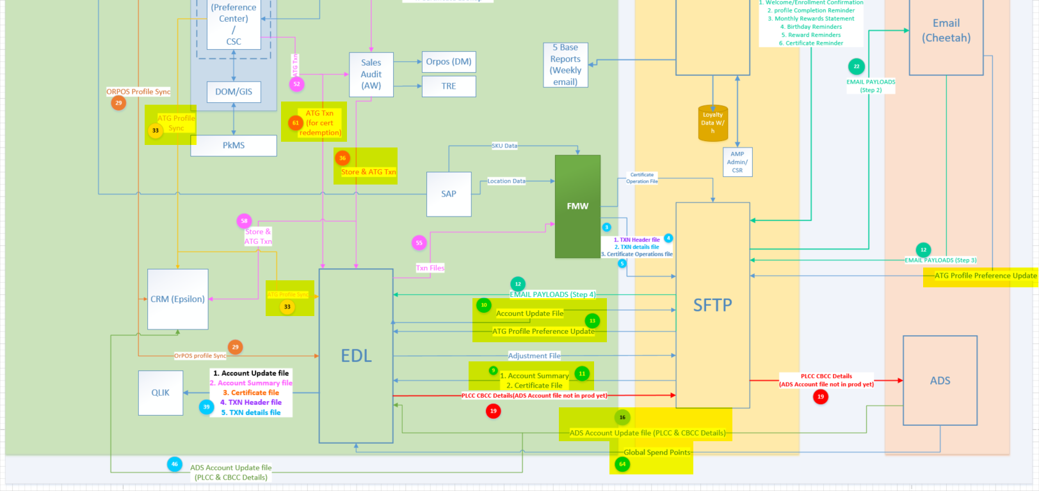

Figure 1: Integration Context Diagram – Inbound Highlighted

### Inbound Data Feeds to the EDL

The following inbound feeds into the EDL are used by the premium Loyalty Program. When highlighted, they correspond to an integration point in the above integration context diagram. These feeds are landing in the staging area of the EDL.

* Used for “Global Spend” points awarded by ADS - #64 on diagram
  + ANN_ANN_SM_DIV176_STDPNT_REQ
  + ANN_ANN_SM_DIV177_STDPNT_REQ
* Used for completed transactions from Audit Works (Sales Audit System) – Includes store and online transactions - # 36 on diagram
  + ann_ann_aw_transactions_header
  + ann_ann_aw_transactions_line
  + ann_ann_aw_transactions_merchdtl
  + ann_ann_aw_transactions_discountdtl
  + ann_ann_aw_transactions_returndtl
  + ann_ann_aw_transactions_custdtl
  + ann_ann_aw_transactions_linenotes
* Used for online transaction details that do NOT flow through the Audit Works system - #61 on diagram
  + ann_ann_atg_transactions
* Used for online customer profile - #33 on diagram
  + ann_ann_atg_profile
* Used for customer loyalty membership data (account, points, certificates)
  + ANN_ANN_OB_ACCOUNT_UPDATES - #10 on diagram
  + ANN_ANN_OB_ACCOUNT_SUMMARY - #11 on diagram
  + ANN_ANN_OB_ACCOUNT_CERTIFICATE - #11 on diagram
* Used for customer profile information (additional attributes not saved in online customer profile) - #13 on diagram
  + ann_annincloft_profile
  + ann_anntaylor_profile
* Used for customer card holder information (PLCC and CBCC) - #16 on diagram
  + ann_ann_ads_custdailyplcc_type01
  + ann_ann_ads_custdailycbcc_type01
  + ann_ann_ads_custmthlyplcc_type0
  + ann_ann_ads_custmthlycbcc_type0

### Integration Context Diagram – Outbound Highlighted

* Highlighting Outbound Data Feeds from the EDL

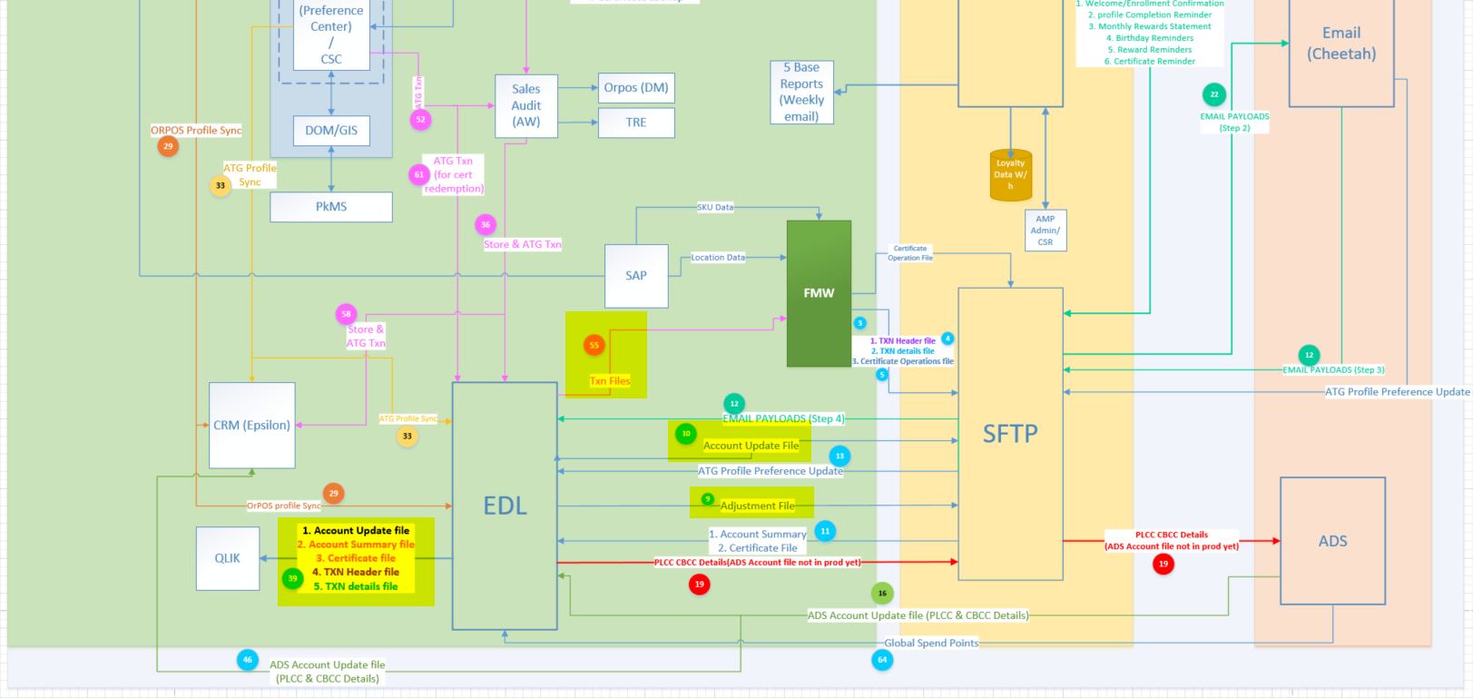

Figure 2: Integration Context Diagram – Outbound Highlighted

### Outbound Data Feeds from the EDL

The following outbound feeds from the EDL are created by the ANN Loyalty Program. When highlighted, they correspond to an integration point in the above integration context diagram.

* Used to feed the ANN Loyalty dashboard in QLIK - #39 on diagram
  + loy_ann_rpt_account_summary
  + loy_ann_rpt_account_updates
  + loy_ann_rpt_certificate_detail
  + loy_ann_rpt_trans_header
  + loy_ann_rpt_trans_detail
* Used to feed the transaction header and detail data to FMW for transformation. **NOTE**: Transaction detail data includes certificate usage. - #55 on diagram
  + loy_ann_trans_header
  + loy_ann_trans_detail
* Used to feed the account updates to Kobie (Appended attributes such as CBCC/PLCC indicators, Profile Complete Flag, and Preferred Name) - #10 on diagram
  + loy_ann_acct
* Used to feed the “Global Spend” points to Kobie - #9 on diagram
  + loy_ann_adjustment

### Overall Outbound Feed Execution Architecture

Each outbound feed follows the same execution pattern as seen in the diagram below.

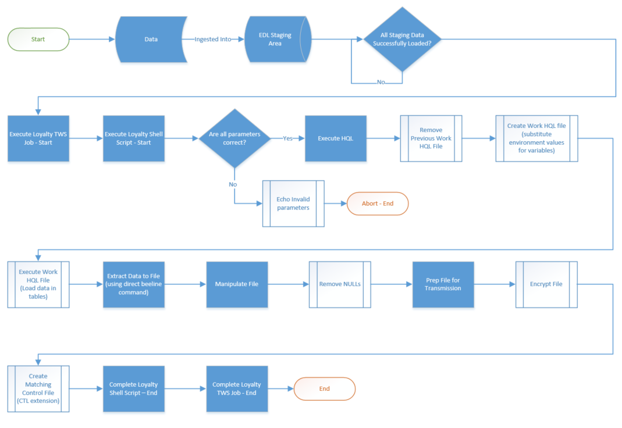

Outbound feeds are invoked by a TWS job that executes a shell script which performs all the work necessary. TWS jobs are built with dependencies so that staging data must be loaded into HIVE first before the outbound feed job will run.

### Outbound Transaction Feed

#### Process Flow Diagram

The process flow diagram for the outbound transaction feed can be found in the “Premium Loyalty Program - Outbound Data Feed Process Flow.vsdx” document.

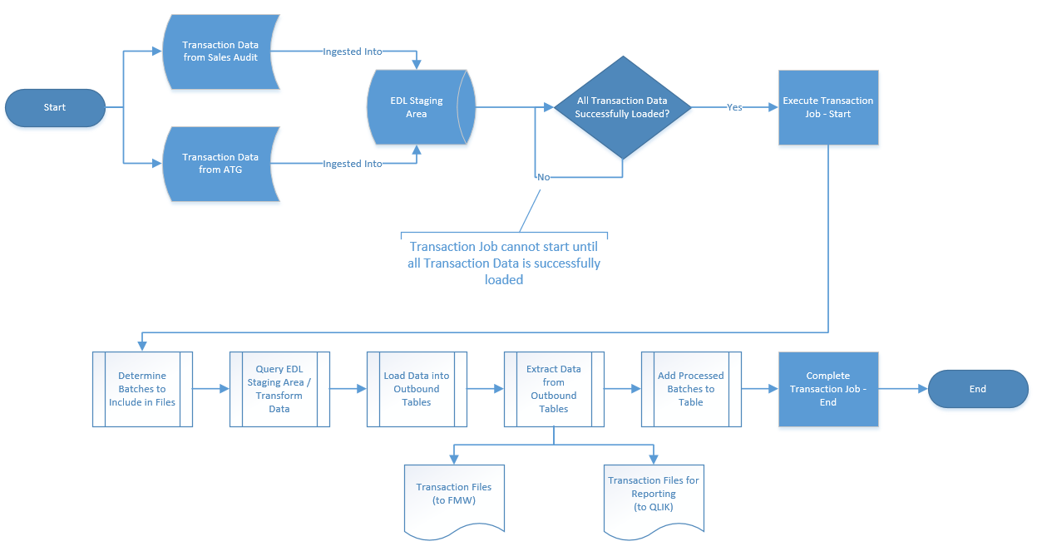

#### Interface Agreement

The interface agreement for the outbound transaction feed can be found in the “Premium Loyalty Program - EDL to FMW Interface Agreement.xlsx” document. Below is an example screen shot. The interface is agreement is separated between the transaction header and transaction detail files; each one defined on a separate tab of the spreadsheet.

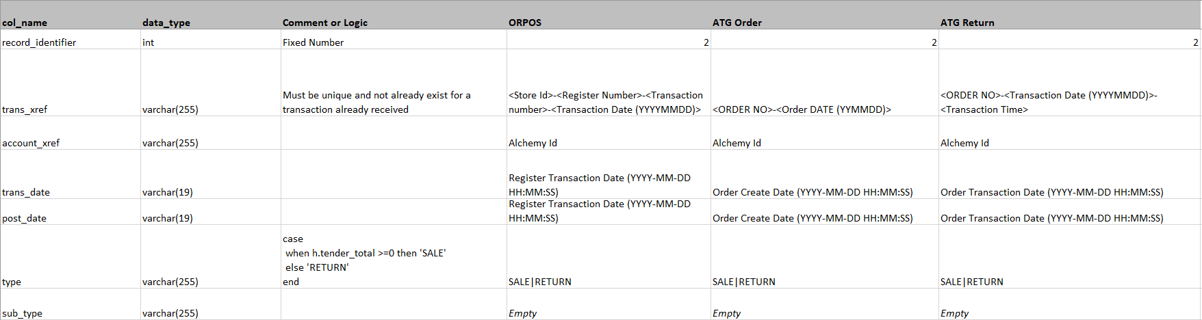

#### Mapping Document

The mapping document for the outbound transaction feed can be found in the “Premium Loyalty Program - EDL Mapping to Loy Outbound Mart.xlsx” spreadsheet. Below is an example screen shot. The mapping document is separated between the transaction header and transaction detail files; each one defined on a separate tab of the spreadsheet.

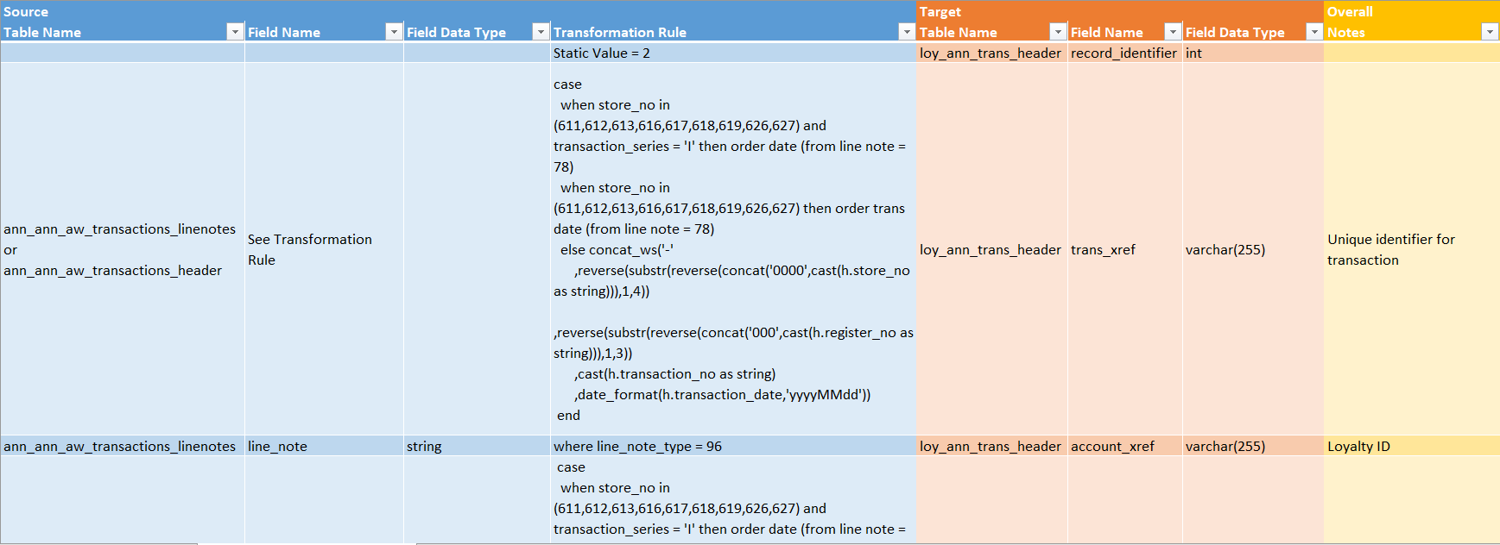

### Outbound Account Update Feed

#### Process Flow Diagram

The process flow diagram for the outbound account update feed can be found in the “Premium Loyalty Program - Outbound Data Feed Process Flow.vsdx” document.

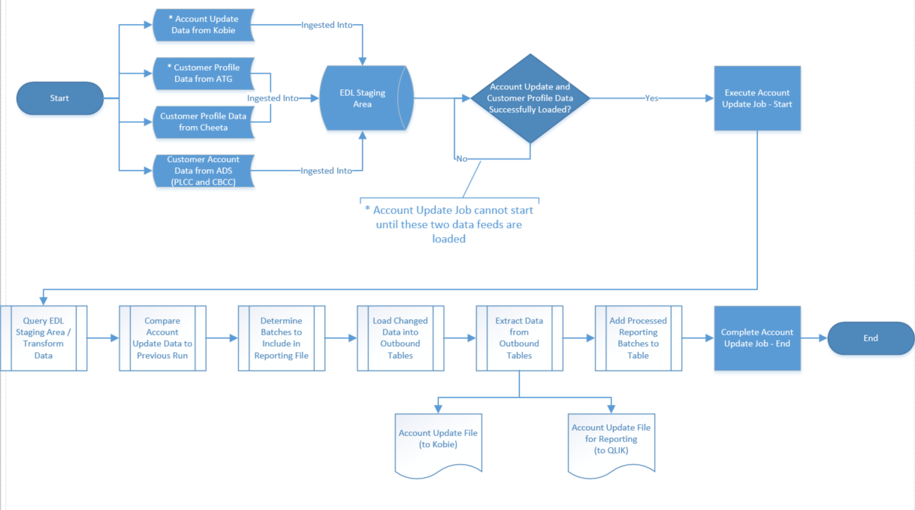

#### Interface Agreement

The interface agreement for the outbound account update feed can be found in the “Premium Loyalty Program - EDL to Kobie Interface Agreement.xlsx” document. Below is an example screen shot.

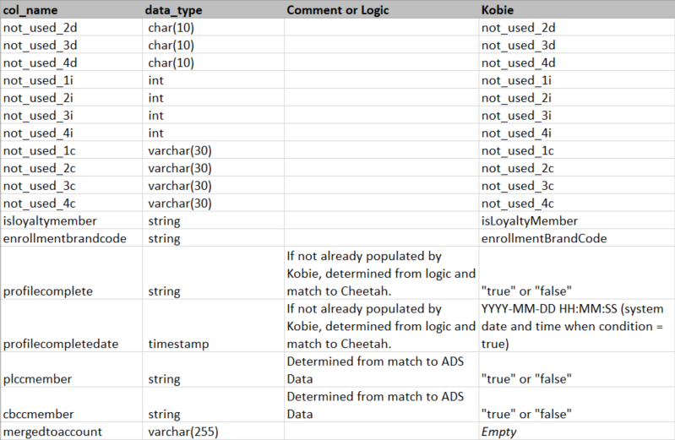

#### Mapping Document

The mapping document for the outbound account update feed can be found in the “Premium Loyalty Program - EDL Mapping to Loy Outbound Mart.xlsx” spreadsheet. Below is an example screen shot.

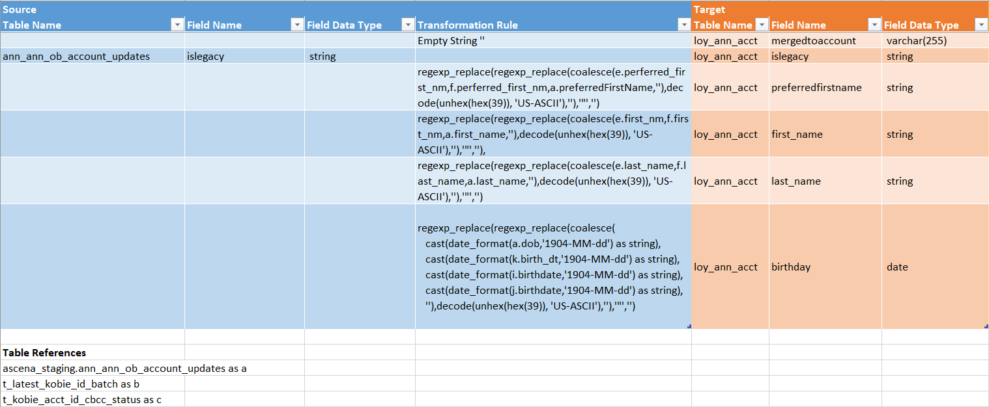

#### Matching Logic Diagram – Get from Dixit (he will send the link)

### Outbound Adjustment Feed

#### Process Flow Diagram

The process flow diagram for the outbound adjustment feed can be found in the “Premium Loyalty Program - Outbound Data Feed Process Flow.vsdx” document.

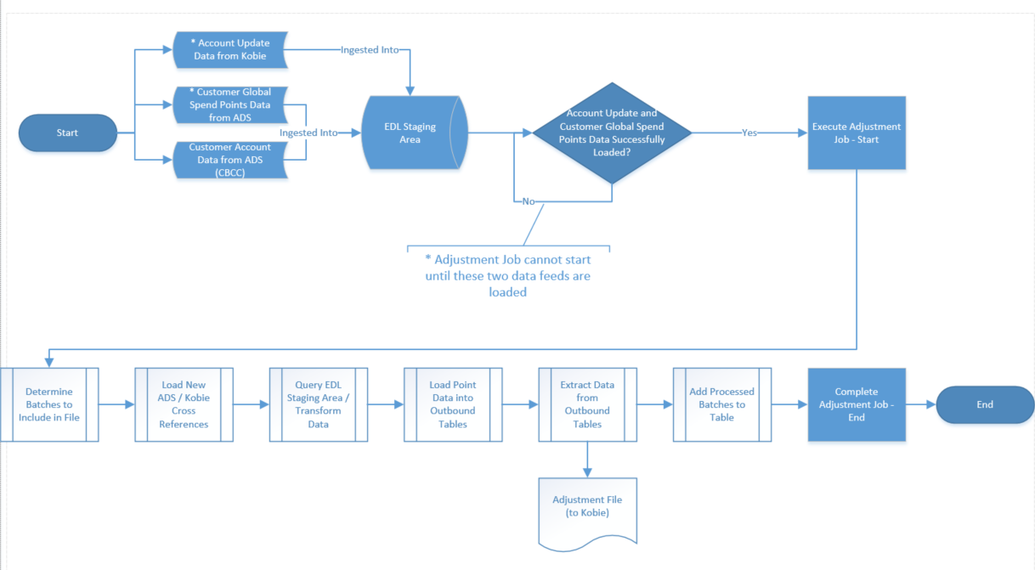

#### Interface Agreement

#### Mapping Document

#### Matching Logic Diagram

### Outbound Account Update Reporting Feed

#### Process Flow Diagram

The process flow diagram for the outbound account update reporting feed can be found in the “Premium Loyalty Program - Outbound Data Feed Process Flow.vsdx” document.

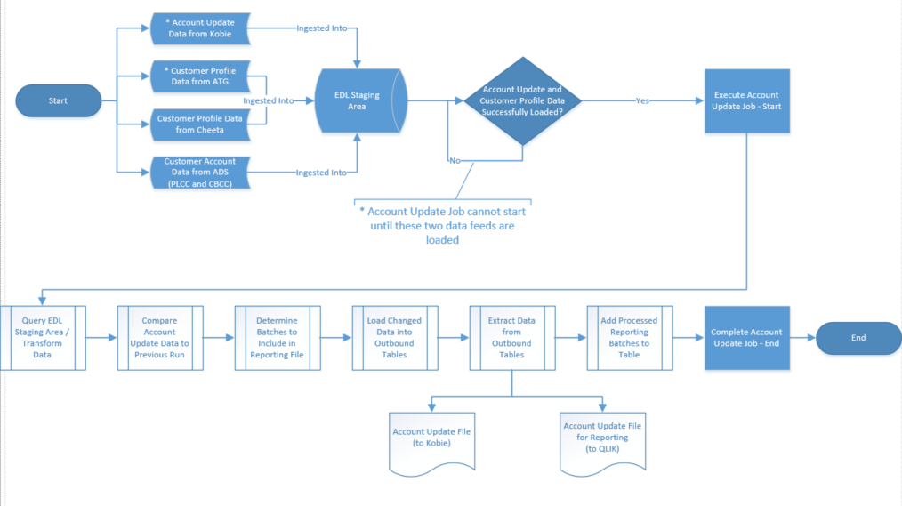

The account update reporting feed process is tightly coupled with the account update feed to Kobie. This ensures that the same updates go to both parties for processing.

### Outbound Account Summary Reporting Feed

#### Process Flow Diagram

The process flow diagram for the outbound account update reporting feed can be found in the “Premium Loyalty Program - Outbound Data Feed Process Flow.vsdx” document.

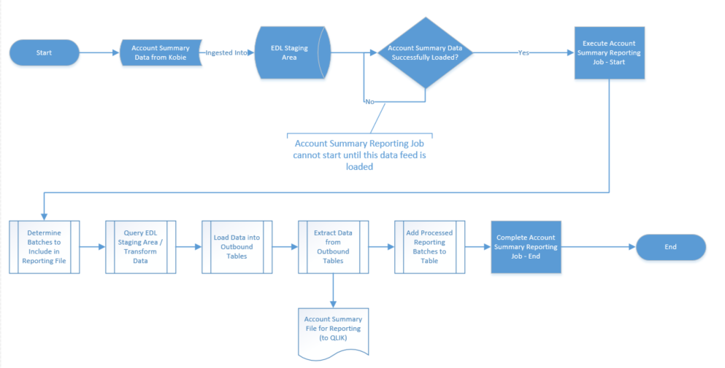

### Outbound Account Certificate Reporting Feed

#### Process Flow Diagram

The process flow diagram for the outbound account update reporting feed can be found in the “Premium Loyalty Program - Outbound Data Feed Process Flow.vsdx” document.

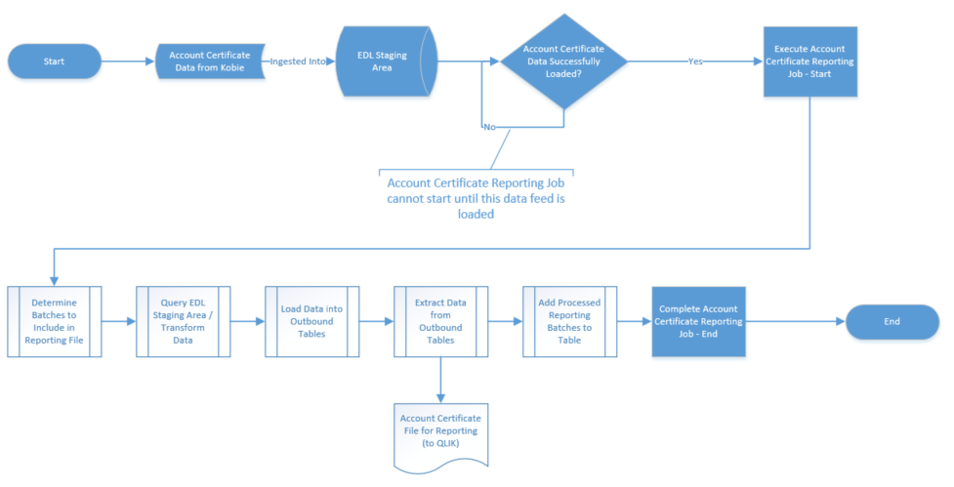

### Outbound Transaction Reporting Feed

#### Process Flow Diagram

The process flow diagram for the outbound account update reporting feed can be found in the “Premium Loyalty Program - Outbound Data Feed Process Flow.vsdx” document.

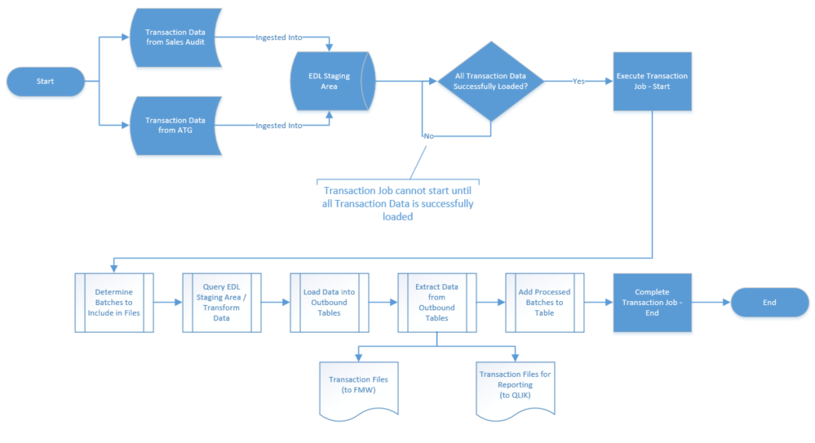

The transaction reporting feed process is tightly coupled with the transaction feed to Kobie. This ensures that the same updates go to both parties for processing.

# Security and Access Control

* The service account used by the TWS job streams that produce the outbound files must have appropriate access to all required HIVE databases and Edge Node directories.
  + Service account needs read only access to source tables, but will need read/write access to any tables used for the outbound data.
  + Service account will need read/write access to the Edge Node directories for outbound files.
  + Service account will need read/write access to the Edge Node directories where the code is deployed
* The service account used by the TWS job streams that produce the outbound files must have the necessary Ascena pgp key to encrypt the files.
* User accounts that need to research or troubleshoot the program must have appropriate access to all required HIVE databases and Edge Node directories.
  + User accounts need at least read permissions to tables.
  + User accounts need at least read permissions to the Edge Node directories for outbound files.

# Program Configuration

The Premium loyalty program can be configured/reconfigured in the following aspects.

| Configuration Option | Method to Configure |
| --- | --- |
| Schedule | Modify the TWS job schedules |
| Location and /or Name of Shell Scripts on the Edge Node | Modify the TWS job commands |
| Location and /or Name of HQL Files on the Edge Node | Modify the SQL_PATH and/or QUERY_FILE variable values in the shell scripts |
| Hive Connection String | Modify the CONNECT_STRING variable value in the shell scripts |
| Hive Database Names | Modify the STAGING and/or MARTDATABASE variable values in the shell scripts |
| Hive Table Names | Modify the necessary *TABLE* variable values in the shell scripts |
| Edge Node File Paths | Modify the necessary *PATH* variable values in the shell scripts |

# Configuration Management

## Code Repository

Versions of the code are stored in the following EDL GIT repository.

<https://l02pigithub01.corp.local/Ascena-CEM/Loyalty-Premium>

## Backup and Restore Procedures

### GIT Backup and Restore (recommended)

All code versions should be stored in the EDL GIT repository. **These code versions can be used for backup and restore purposes as long as all code changes deployed to production are reflected in this GIT repository. Failure to include code versions in the GIT repository may cause significant disruption to the premium Loyalty Program in the event of a disaster.**

Assumption is that Ascena has regular backups running against the company GIT repositories that would allow the EDL team to restore these repositories in the event of a disaster to the GIT system.

### CommVault Backup and Restore

IBM has implemented an OS level backup system using CommVault. This ***may*** include backups of the deployed code. It ***may*** be possible to restore the shell scripts or HQL files from a dated backup by engaging the IBM prod support team.

### Online Backup and Restore

Temporary “online” backups of the code can be stored in the archive directory where the shell scripts and HQL files are deployed. A dated directory can be created and the files copied to the directory. Currently those paths are:

/ascena_prod/asc/src/loy/scripts/archive

/ascena_prod/asc/src/loy/sql/archive

This can be completed prior to production deployments if necessary.

To restore from these “online” backups, the shell scripts or HQL files can be copied from the backup locations back to the primary locations.

# Monitoring and Alerting

## Daily Operational Monitoring and Alerting

The IBM prod support team currently monitors the TWS jobs that are scheduled to generate and extract the data for the ANN Loyalty Program. Each of these jobs has predecessors that must run successfully before they will be triggered to run. This can be found in the “TWS-Job_Schedule-Ascena Retail.xlsx” spreadsheet (link included later in this document).

This spreadsheet will include the TWS job stream name that produces the outbound files, its associated predecessor job streams along with some of their attributes.

The following screen shot is an example of the information contained in the above mentioned spreadsheet.

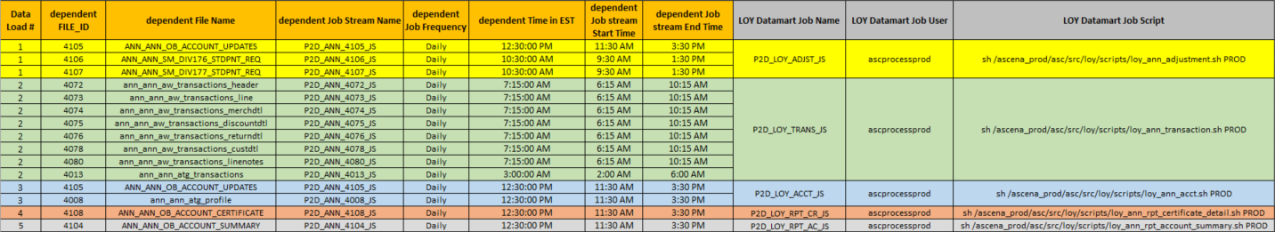

Using the above example, you can see that the P2D_LOY_TRANS_JS job stream has 8 predecessor jobs that will need to run successfully before it will execute.

Frequently throughout the day, the IBM prod support team will email the status of the TWS outbound jobs that are critical for the ANN Loyalty Program. These emails will report any job failures or delays. Below is an example.

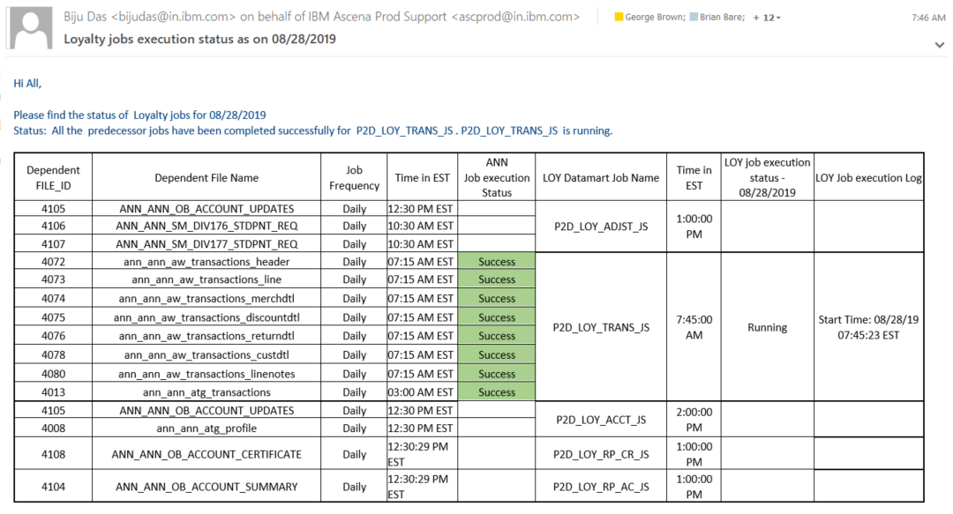

## Error Messages

The execution of any TWS job stream produces a log. If the job encounters an error, the IBM prod support team can provide the corresponding log for further troubleshooting.

## Health Checks

There are no known health checks currently in place.

# Operational Tasks

## Deployment

Currently the code is deployed to the following directories on the Edge Node. **NOTE**: These directories can be changed by following the direction in the Program Configuration section of this document.

/ascena_prod/asc/src/loy/scripts/

/ascena_prod/asc/src/loy/sql/

Follow these steps to deploy code:

1. Backup production code to ./archive directories (optional)
2. Download appropriate version of code from GIT repository
3. Copy code from GIT repository to Edge Node directories using service account (overwrite existing)

## Troubleshooting

# Maintenance Tasks

## Maintenance Procedures

### Code Branching

### Code Review

### Code Merging

## Testing (pre deployment)

## Validation (post deployment testing)

# Failure and Recovery Procedures

## Troubleshooting

When a TWS job fails, you will need to request a copy of the job failure log in order to troubleshoot further. This log will have the list of commands run along with error messages or alerts. Simply rerunning the TWS jobs may not correct the issue.

## Rerunning TWS Jobs

If a TWS job fails, and you have corrected the underlying issue, you will need to review the following tables (depending on the TWS job) to determine if the batch ID to be targeted has already been loaded or not.

* loy_ann_trans_header_loaded_batch_id: For the transaction header and detail files
* loy_ann_adjustment_loaded_batch_id: For the adjustment file
* loy_ann_adjustment_daily_cbcc_loaded_batch_id: For the checking the CBCC and PLCC feeds to match ADS accounts to Kobie accounts
* loy_ann_rpt_account_summary_loaded_batch_id: For the account summary report file
* loy_ann_rpt_account_updates_loaded_batch_id: For the account updates report file
* loy_ann_rpt_certificate_detail_loaded_batch_id: For the certificate detail report file

The code to produce the files when executed, will first examine the batch IDs in its respective table and then compare to the batch IDs available in the staging tables. It will then target the batch IDs that have not been previously loaded into a file. Once the files are successfully created, the code inserts the batch IDs into these tables.

If you need to generate a file that had previously been generated successfully, you would need to remove the batch IDs you wish to target from the associated tables, then rerun the jobs.

# Contact Details

| Contact | Role | Email | Phone |
| --- | --- | --- | --- |
| EFT Team | Manages and maintains all EFT jobs to transmit files to/from the EDL | SSG-APP-EFT-Support@AscenaRetail.com | N/A |
| FMW Team | Manages and maintains all FMW processes to transform files from EDL to Kobie | SSG-APP-EBS-Middleware-Support@AscenaRetail.com | N/A |
| IBM Prod Support | Manages and monitors all TWS jobs | ascprod@in.ibm.com | N/A |
| George Brown | IT Data Architect for EDL, Initial Developer of ANN Loyalty EDL Code | george.brown@ascenaretail.com | 1-740-971-8347 |
| Loyalty Leads | Owners of ANN Loyalty Program for the Enterprise | Loyaltyleads@AscenaRetail.com | N/A |
| Loyalty Prod Support Team | Production Support Team for ANN Loyalty Program | Loyalty-Prod-Support@AscenaRetail.com |  |

# Additional Document References

| # | Document Name | Document Link | Notes |
| --- | --- | --- | --- |
| 1. | ANN Brands Data Ingestion to EDL – Operation Manual.docx |  | Loading of data into staging in hive – predecessor |
| 2. | EDL - File and Data Orchestration.xlsx |  | EFT Job Details for outbound |
| 3. | TWS-Job_Schedule-Ascena Retail_V11.2.xlsx |  | TWS Jobs for Outbound Files |
|  | Premium Loyalty Program - Solution Integration Context Diagram - Inbound to EDL Highlighted.png |  |  |
|  | Premium Loyalty Program - Solution Integration Context Diagram.pdf |  | Link to Smart Sheets?  Link to EDL Operations Sharepoint Site AND Smart Sheets |
|  | Premium Loyalty Program - Solution Integration Context Diagram - Outbound from EDL Highlighted.png |  |  |
|  | Premium Loyalty Program - EDL to FMW Interface Agreement.xlsx | [http://epm01/sites/IT_Sites/EnterprisData_Lake_Operations/Shared%20Documents/Operation%20Manuals/Premium%20Loyalty%20Program%20-%20EDL%20to%20FMW%20Interface%20Agreement.xlsx](http://epm01/sites/IT_Sites/EnterprisData_Lake_Operations/Shared%20Documents/Operation%20Manuals/Premium%20Loyalty%20Program%20Documents/Premium%20Loyalty%20Program%20-%20EDL%20to%20FMW%20Interface%20Agreement.xlsx) | Contains the list of data elements sent to FMW for final transform to Kobie interface agreement. Covers the outbound transaction feed; transaction header and transaction detail files. |
|  | Premium Loyalty Program - EDL to Kobie Interface Agreement.xlsx | [http://epm01/sites/IT_Sites/EnterprisData_Lake_Operations/Shared%20Documents/Operation%20Manuals/Premium%20Loyalty%20Program%20-%20EDL%20to%20Kobie%20Interface%20Agreement.xlsx](http://epm01/sites/IT_Sites/EnterprisData_Lake_Operations/Shared%20Documents/Operation%20Manuals/Premium%20Loyalty%20Program%20Documents/Premium%20Loyalty%20Program%20-%20EDL%20to%20Kobie%20Interface%20Agreement.xlsx) | Contains the list of data elements sent to Kobie. Covers the outbound adjustment feed and the outbound account update feed. |
|  | Premium Loyalty Program - Outbound Data Feed Process Flow.vsdx | <http://epm01/sites/IT_Sites/EnterprisData_Lake_Operations/Shared%20Documents/Operation%20Manuals/Premium%20Loyalty%20Program%20Documents/Premium%20Loyalty%20Program%20-%20Outbound%20Data%20Feed%20Process%20Flow.vsdx> | Contains the process flow diagrams for the outbound feeds and the common process. |

# Appendix